

**To Supply Leftover Food to Poor**

College: 7155 - PSG Institute of Technology and Applied Research

Team ID: NM2024TMID00582

Team Lead: HARISH PRASATH V G (DAC1E8472A26363B30140FA7FC7189B6)

Team Members:

|  |  |
| --- | --- |
| DHANUSHKUMAR V | 3B7BDD5A863FD3F921E430F73168F2F1 |
| HARISH PRASATH V G | DAC1E8472A26363B30140FA7FC7189B6 |
| NITHISHKUMAR M V | 8134A8B909AB816BA74489FB9F93A9F7 |
| RAJADURAI M | 848D4C072CA52D5A438480023B058DD4 |
| RAM KUMAR R M | DBEE3DEBECFC9459EF84CD136B28403A |

1. **Project Overview**

This project is focused on Food Connect, designed to address the challenge of efficiently collecting and distributing surplus food to those in need. The goal is to deliver a comprehensive solution by leveraging Salesforce's platform to manage food collection points, volunteers, and distribution tasks. Through this project, we aim to enhance operational efficiency, transparency, and data accuracy in food distribution efforts, supporting the long-term goals of providing sustainable food access and reducing food waste.

1. **Objectives**

**Business Goals:**To improve the efficiency and transparency of surplus food collection and distribution processes by leveraging Salesforce. The project aims to reduce food waste, support sustainablefood access for the needy, and foster community collaboration through organized food logistics.

**Specific Outcomes:**

* Streamlined collection and distribution workflow, reducing operational overhead.
* A user-friendly dashboard to track drop-off points, volunteers, and food distribution progress.
* Accurate data reporting on food collection, distribution, and volunteer engagement.
* Increased accessibility to food resources for underserved communities.

1. **Salesforce Key Features and Concepts Utilized**

This project leverages key Salesforce functionalities and concepts to create a seamless and effective food distribution system:

1. Custom Objects and Relationships
   * Created custom objects like Venue, Drop off Point, Task, Volunteer, and Execution Details to organize and track all essential data.
   * Defined lookup relationships between objects to establish clear connections, ensuring data consistency and easy access.
2. Tabs and Lightning App (Food Connect)
   * Set up tabs for each object for easy navigation within the Food Connect Lightning app.
   * Customized the Lightning app for streamlined access, branding, and organization.
3. Screen Flows
   * Built a Venue Form using Screen Flow to capture important venue details, including location coordinates, for precise drop-off management.
4. Apex Triggers
   * Developed Apex triggers to automate tasks, such as calculating the distance between venues and drop-off points, enabling optimized logistics and efficient route planning.
5. Users and Public Groups
   * Created specific users and public groups (e.g., Iksha Foundation, NSS, StreetCos) for effective team collaboration and data access control.
6. Reports and Dashboards
   * Designed custom report types and reports to provide insights into volunteer activity, food distribution status, and drop-off points.
   * Created a dashboard integrated with the homepage to offer real-time visibility into project metrics and progress.
7. Homepage Integration
   * Integrated the dashboard on the homepage for centralized data monitoring, allowing stakeholders to track the project’s impact at a glance.

These Salesforce features collectively ensure that the project operates with high efficiency, transparency, and data-driven decision-making to maximize food distribution effectiveness.

1. **Detailed Steps to Solution Design**

1. Created Salesforce Developer Account

* We began by creating a Salesforce Developer Account to access a development environment where we could build and customize the application. This setup provided the necessary tools to design, test, and deploy the application.

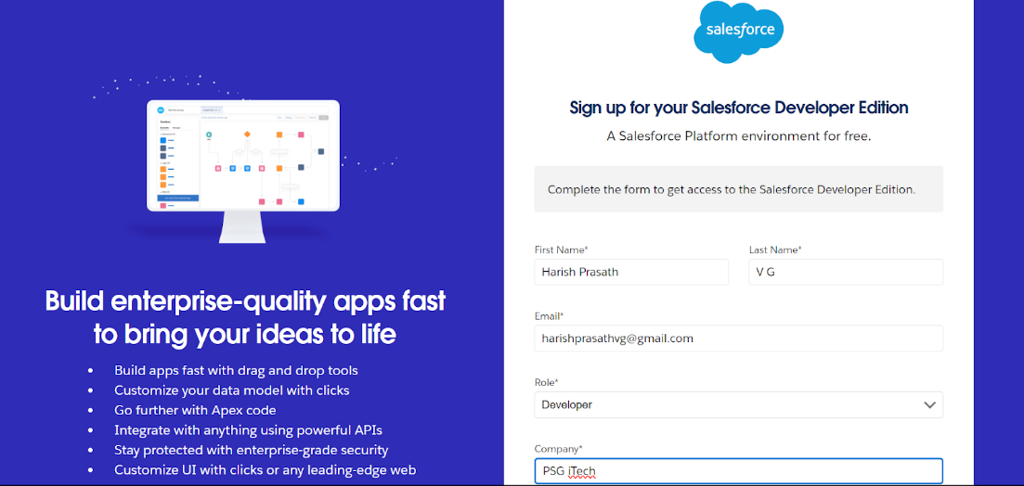

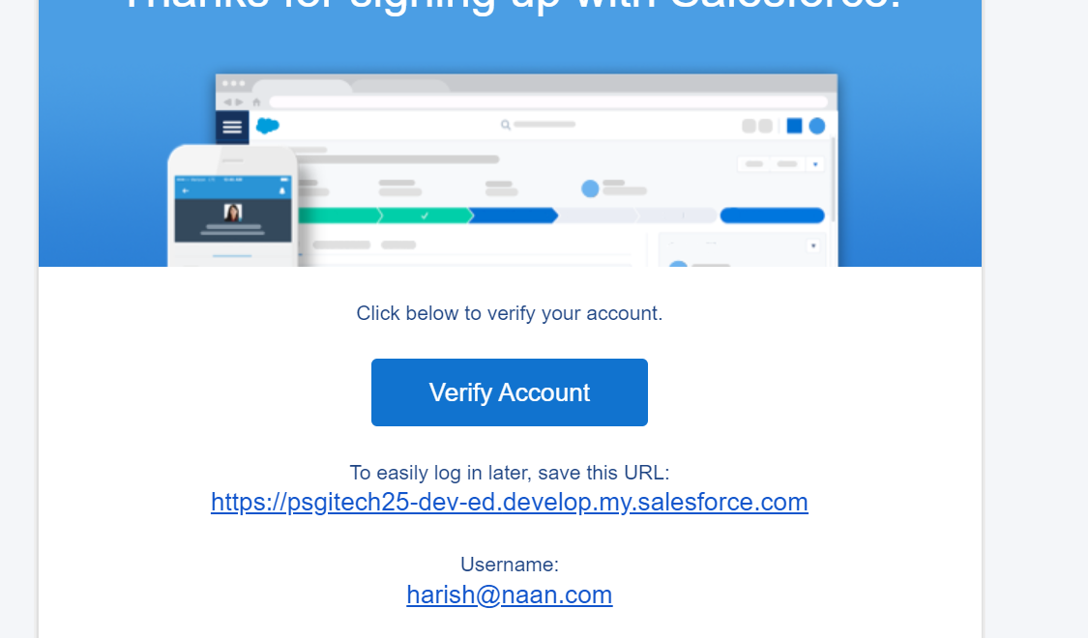

2. Defined Objects

* Five primary objects—Venue, Drop off Point, Task, Volunteer, and Execution Details—were created in Object Manager.
* Each object was designed to store relevant data, such as location details in Venue, task information in Task, and volunteer records in Volunteer.

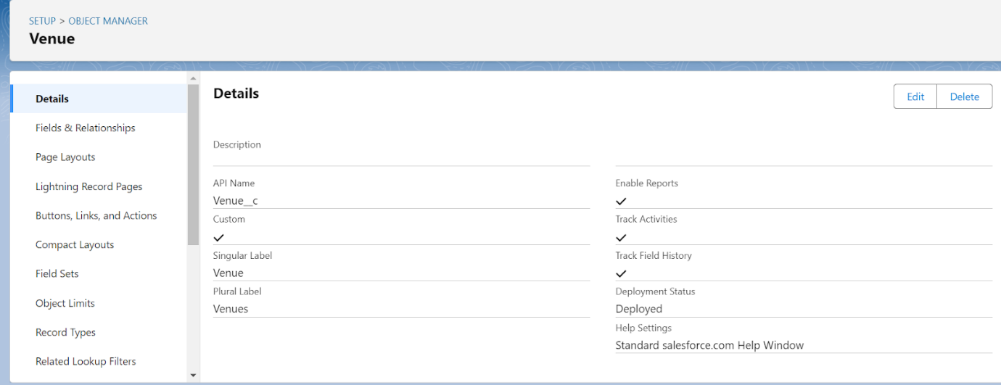

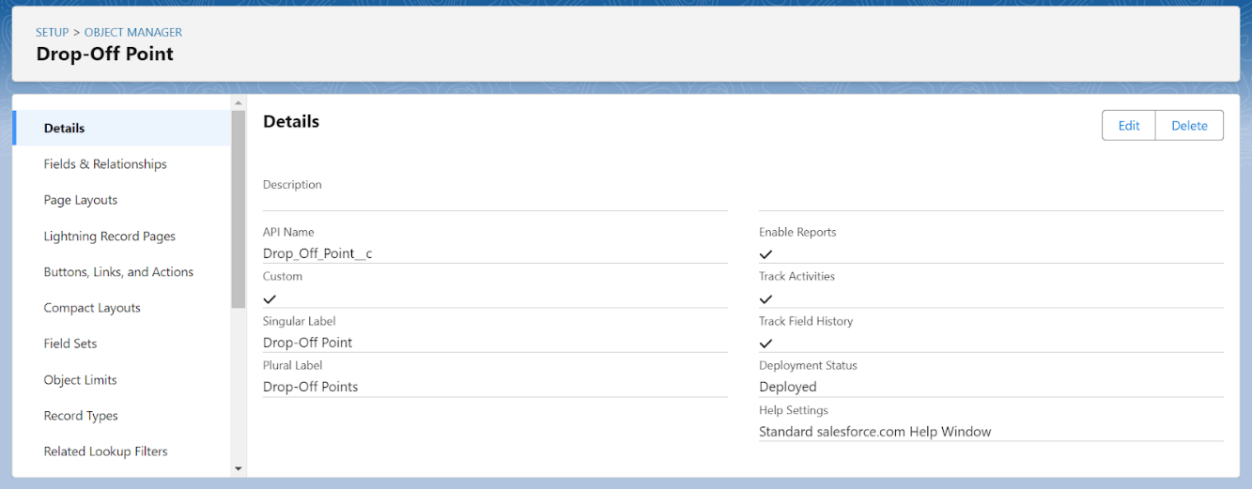

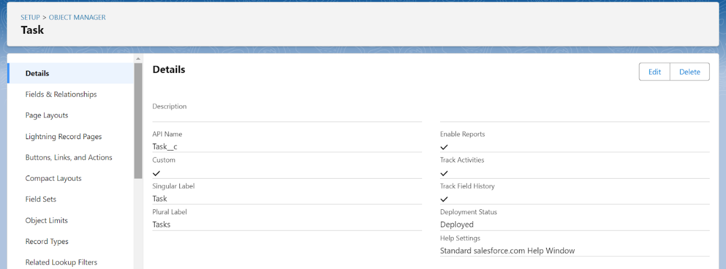

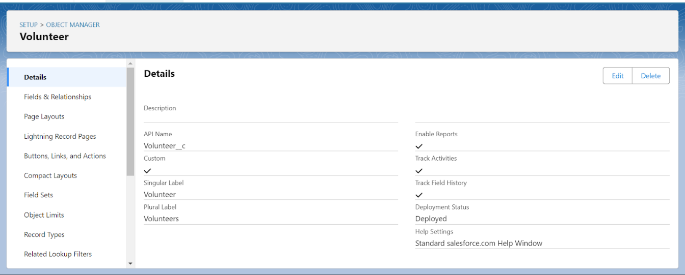

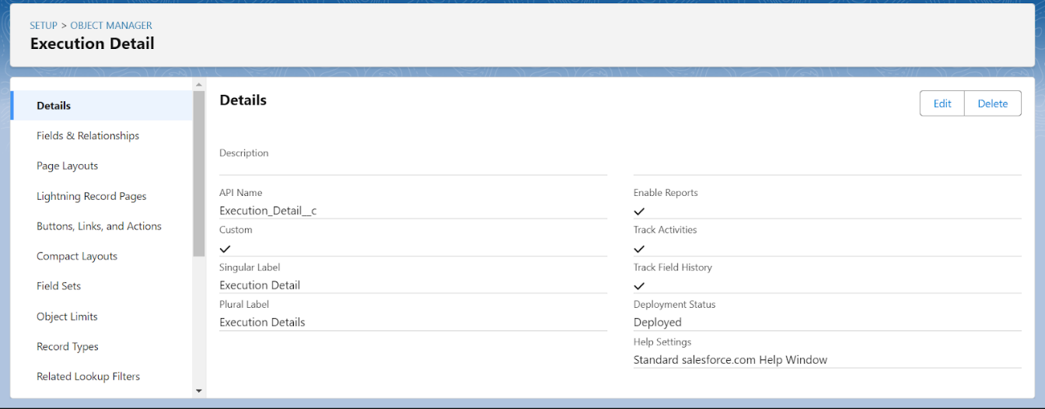

3. Configured Tabs

* Corresponding tabs were created for each of the main objects to facilitate easy access within Salesforce.
* Tabs for Venue, Drop off Point, Task, Volunteer, and Execution Details were set up, allowing users to navigate directly to these data points and manage records effectively.

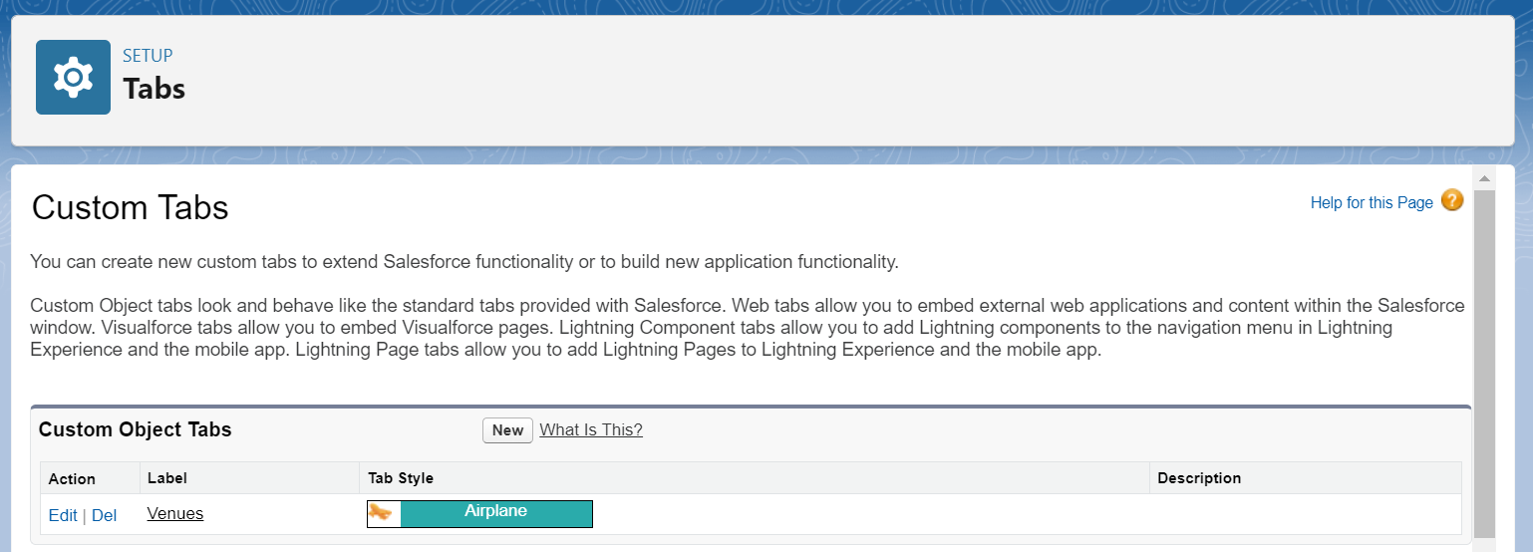

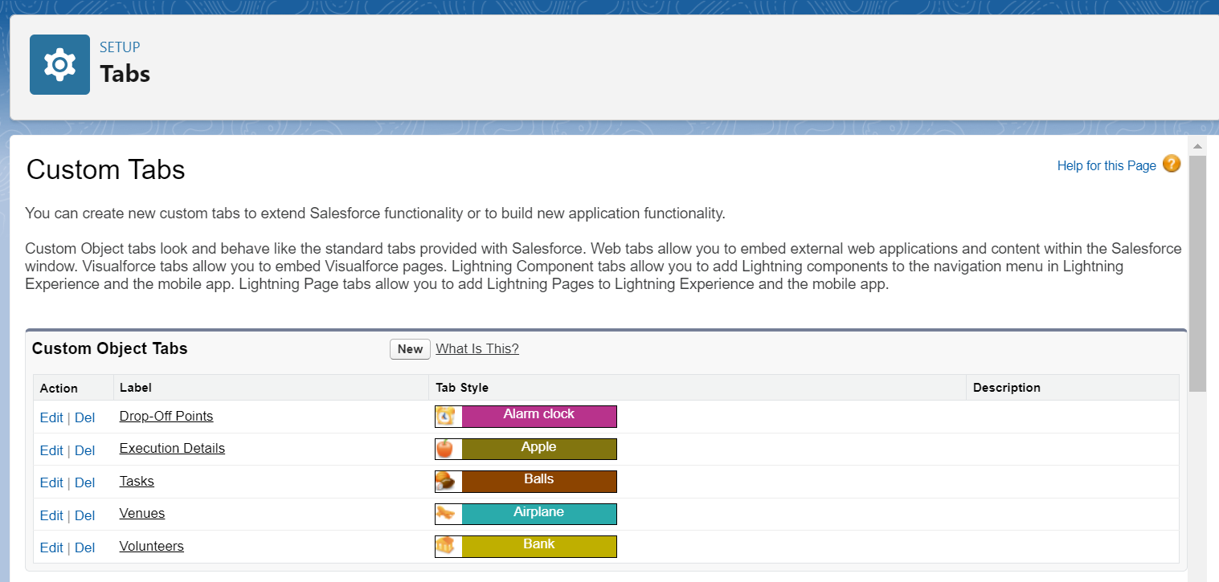

4. Developed the Lightning App

* We created a custom Lightning App named "Food Connect" to consolidate all project functionalities.
* The app was configured with specific branding, navigation items, and user access settings, which made it intuitive and easy to use for project participants.

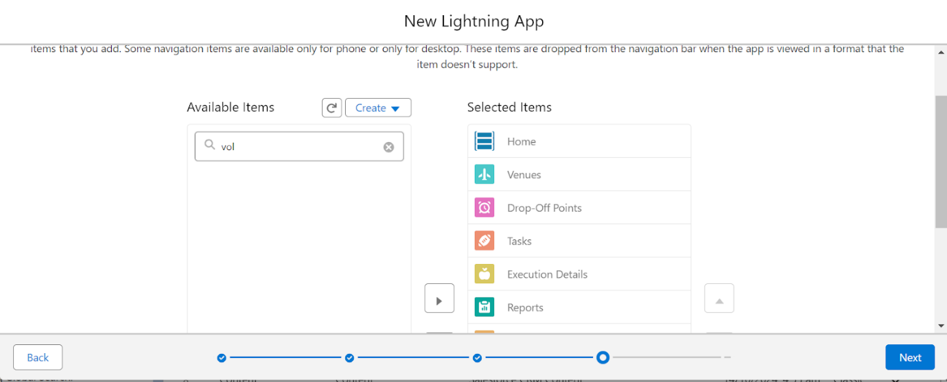

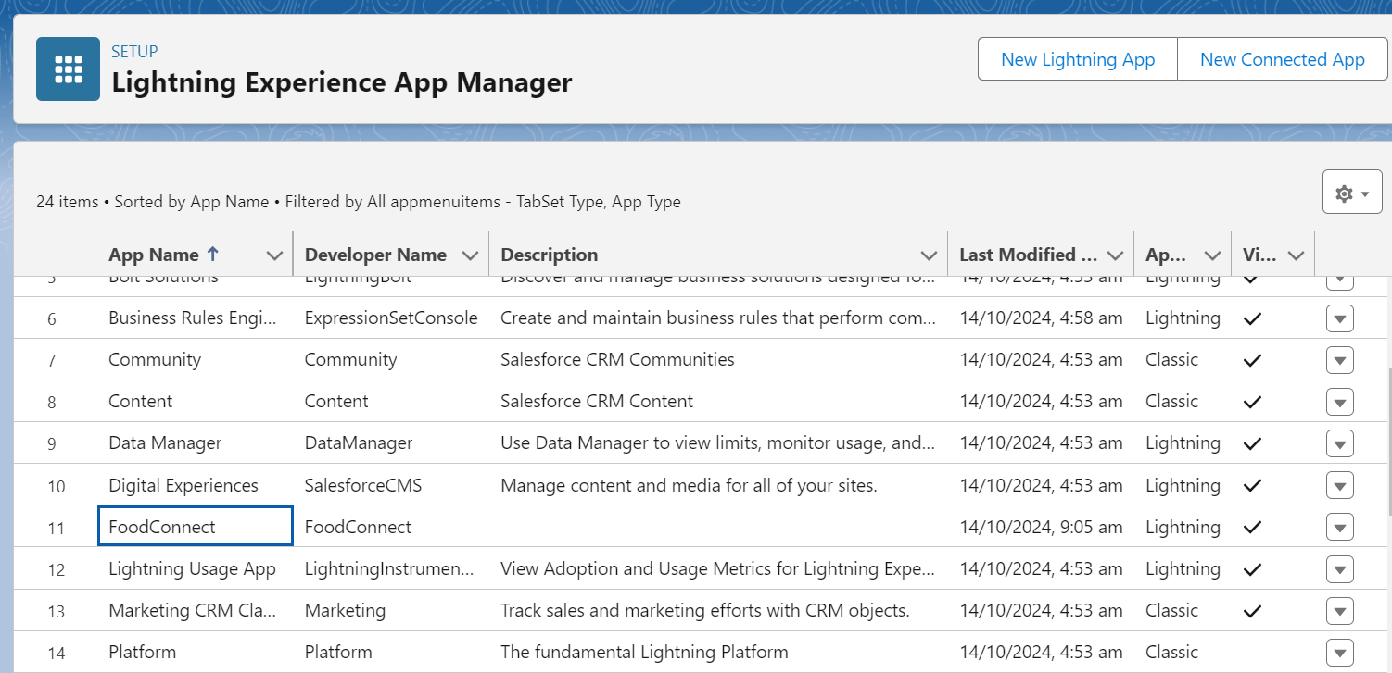

5. Added Fields to Objects

* Custom fields were defined within each object to capture the necessary details:
  + Venue: Location, contact information, capacity.
  + Task: Type of food, quantity, delivery date, and assigned volunteers.
  + Volunteer: Availability, contact information, and skills.
  + Execution Details: Logs with dates, food types, and quantities distributed.
* Validation rules were also established to ensure data integrity, such as requiring fields like contact information and dates.

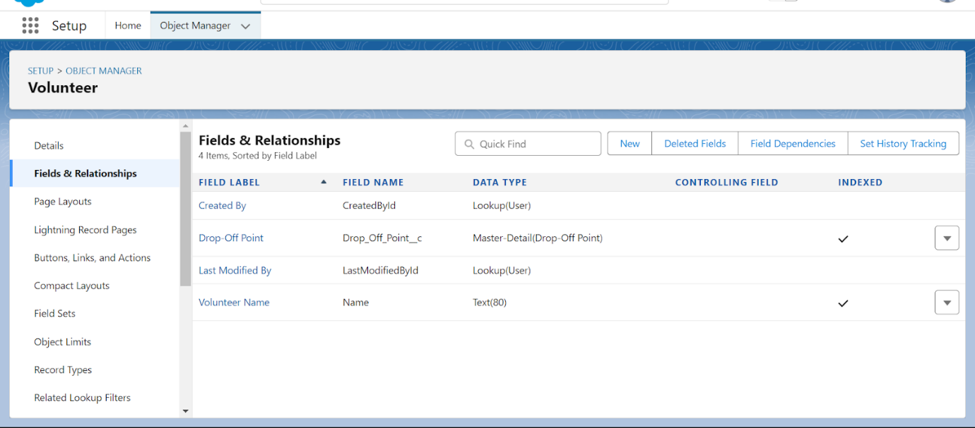

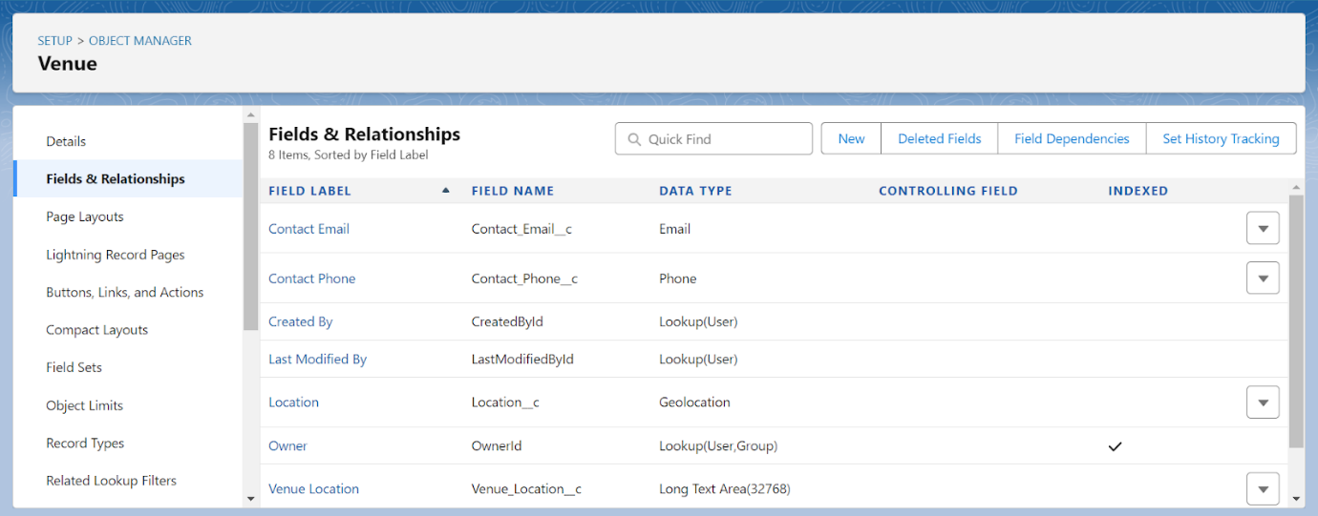

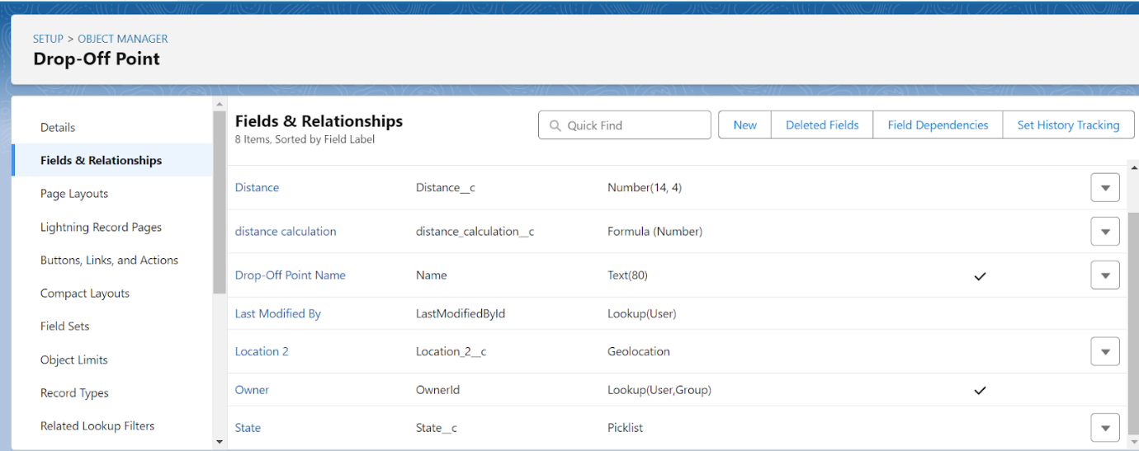

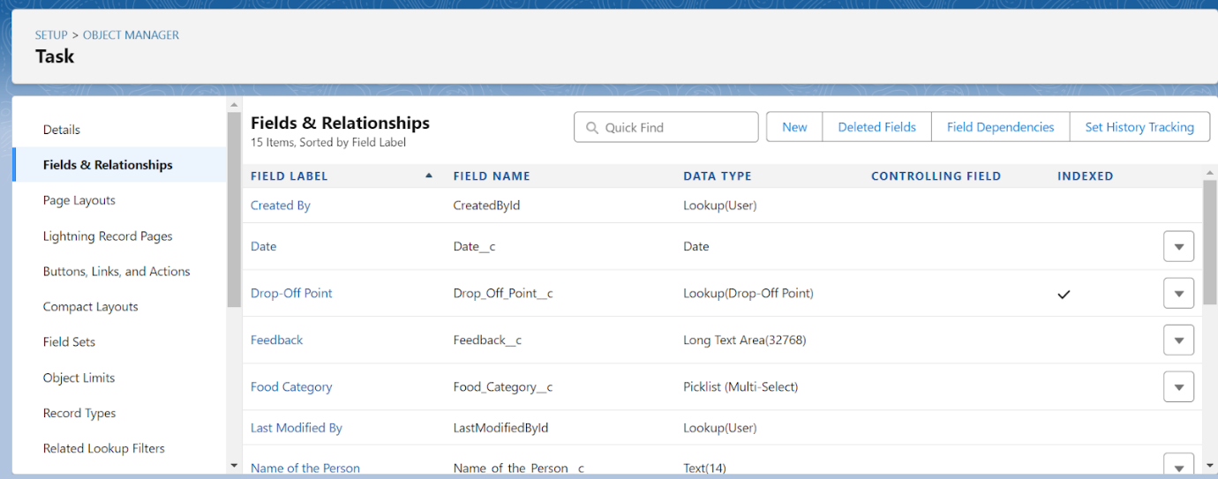

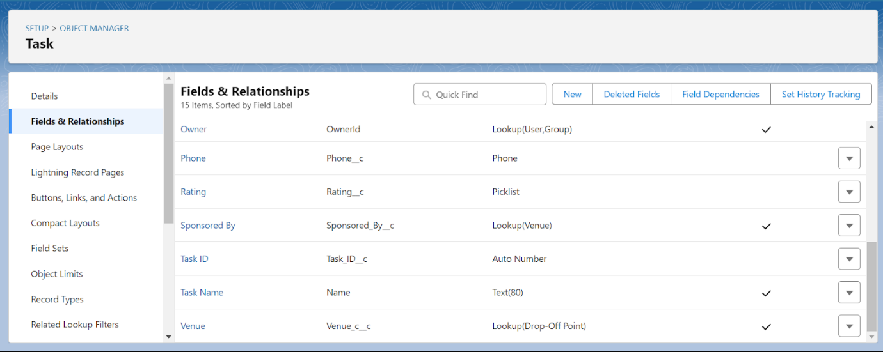

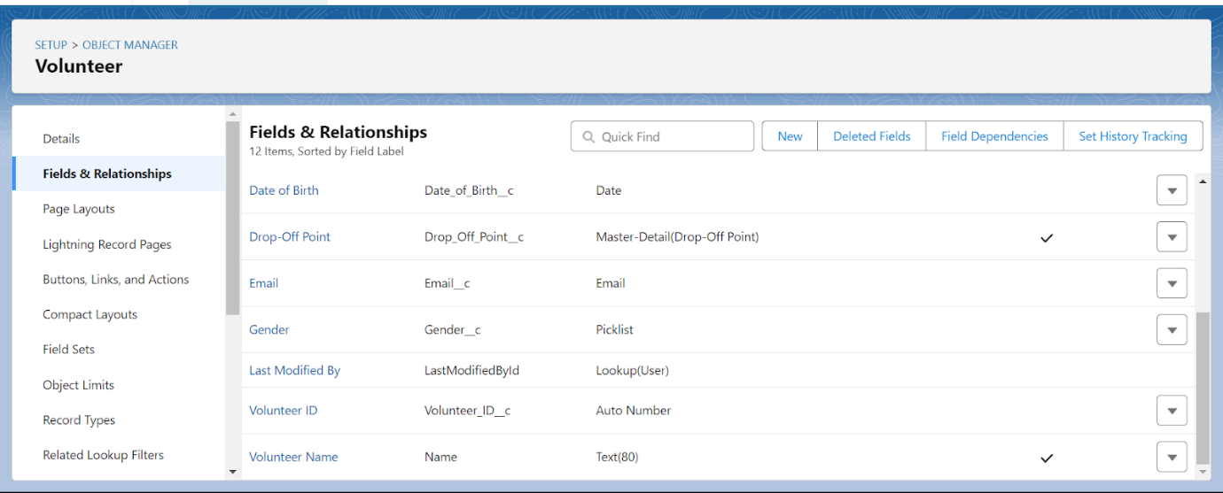

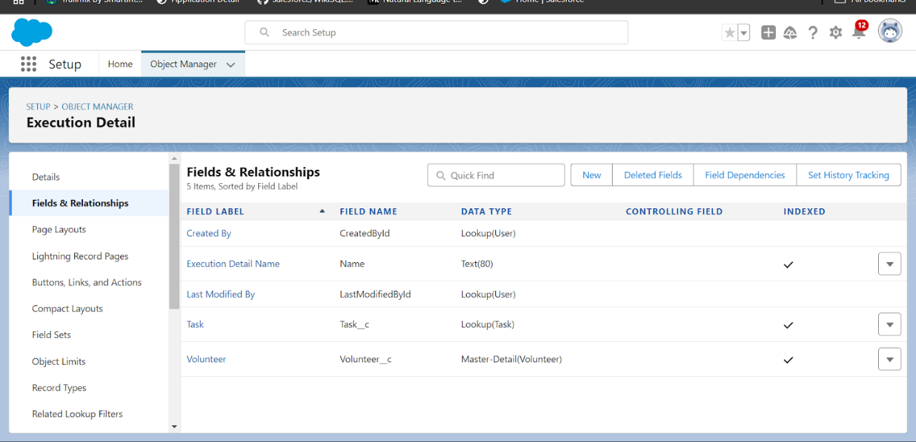

6. Created Flows for Data Entry

* We developed a Screen Flow called "Venue Form" to capture venue details in a step-by-step format.
* The flow included fields for venue name, email, phone, location, latitude, and longitude, making data entry faster and more accurate.

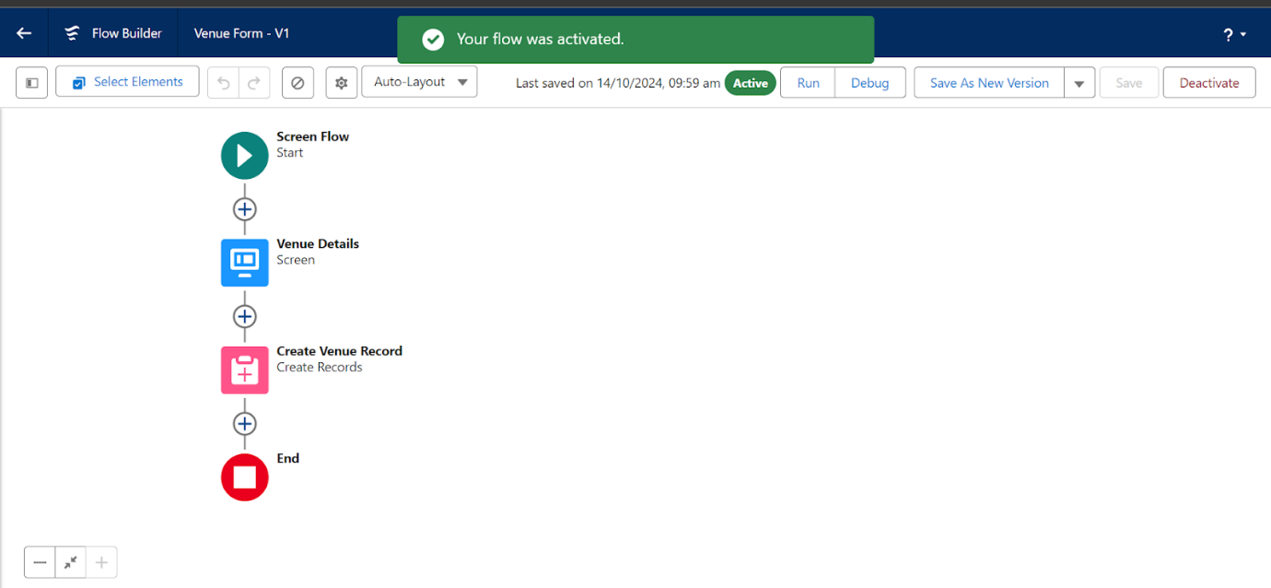

7. Implemented Apex Triggers

* An Apex Trigger was created to automate specific functions, including calculating the distance between drop-off points and venues.
* This automation facilitated optimized routing for volunteers and increased the system's efficiency by reducing manual calculations.

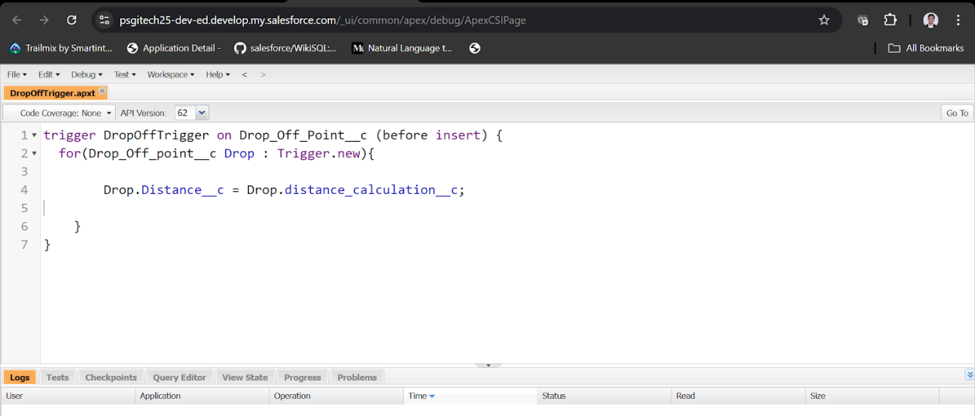

8. Created Users for Different Roles

* We added users representing various partner organizations, such as Iksha Foundation, NSS, and StreetCos.
* Each user was assigned a profile that granted appropriate access based on their role, ensuring secure and organized collaboration within the project.

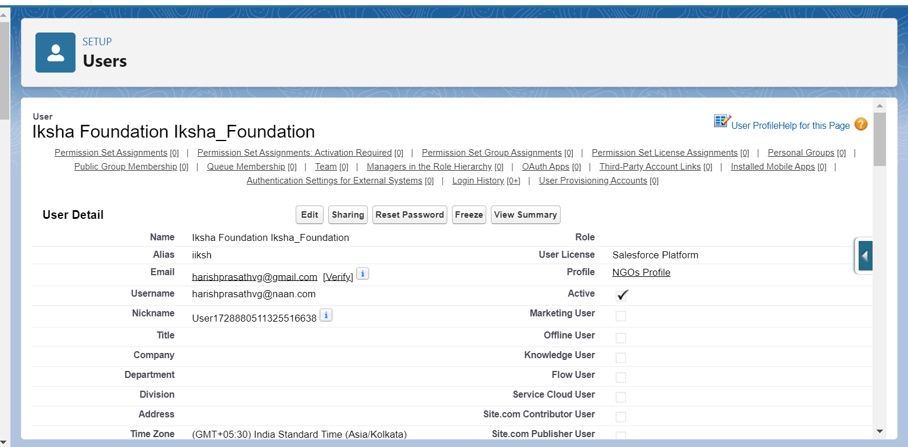

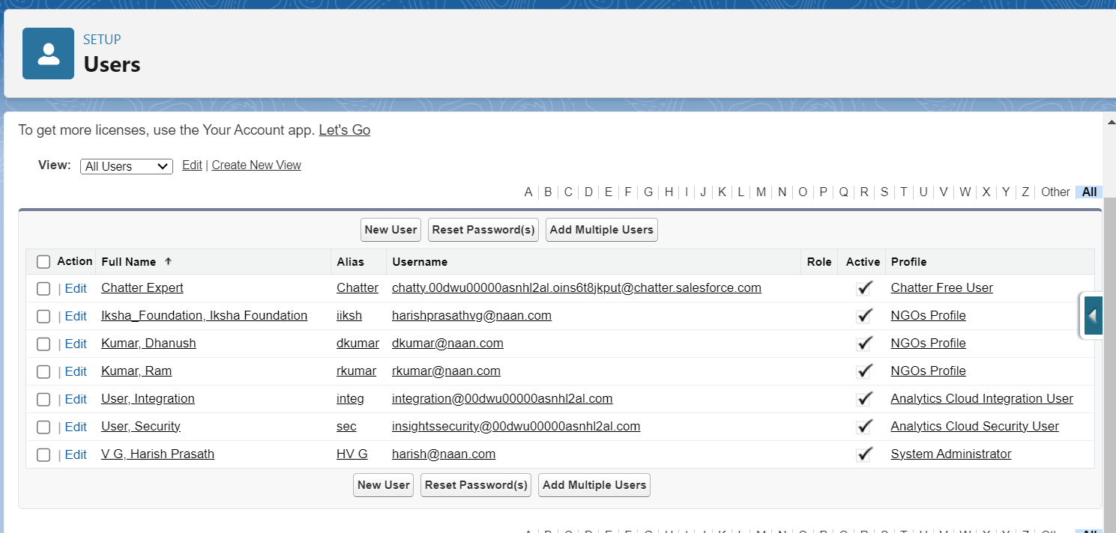

10. Established Public Groups

* Public groups, including Iksha, NSS, and StreetCos, were created to streamline data sharing and collaboration among the project’s participants.
* These groups facilitated quick sharing of reports, records, and tasks, enhancing collaboration between different organizations involved.

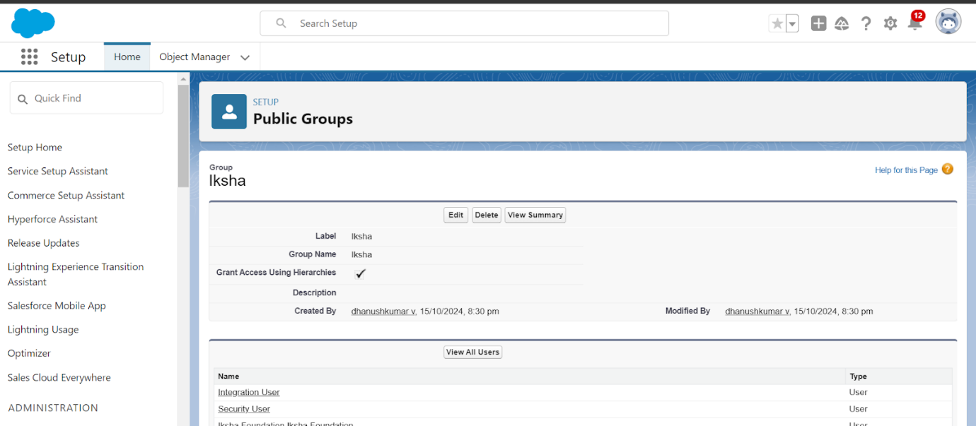

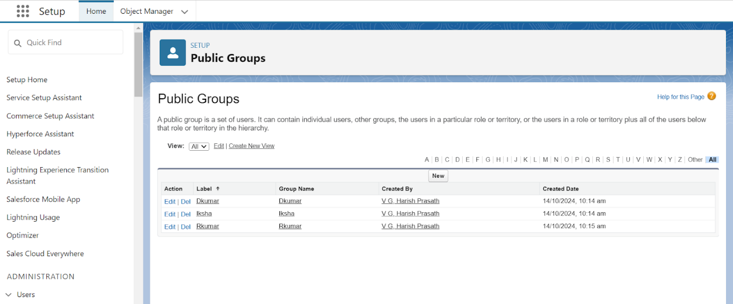

11. Defined Report Types

* Custom report types were created to structure data relationships, such as "Drop off Points with Volunteers with Execution Details."
* These report types were essential in providing a foundation for generating reports tailored to the project’s needs.

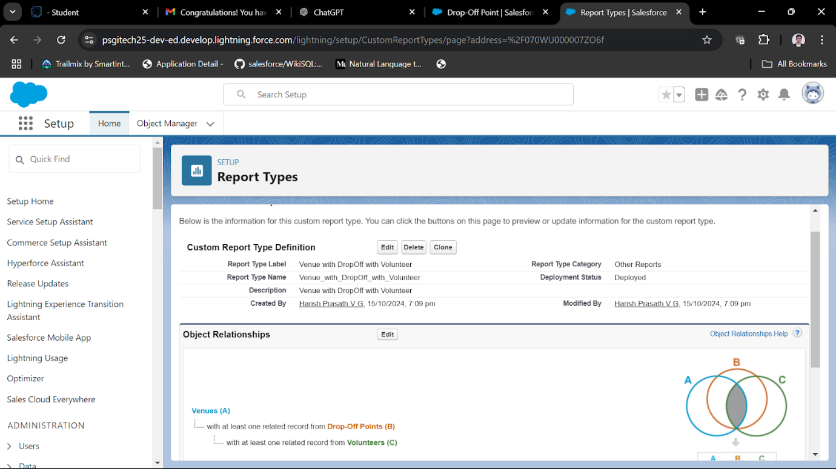

12. Created Custom Reports

* We built several custom reports to monitor key performance metrics, such as volunteer activity, drop-off locations, and distribution data.
* Scheduled reports were configured to send regular updates to stakeholders, ensuring they were informed about project progress and performance.

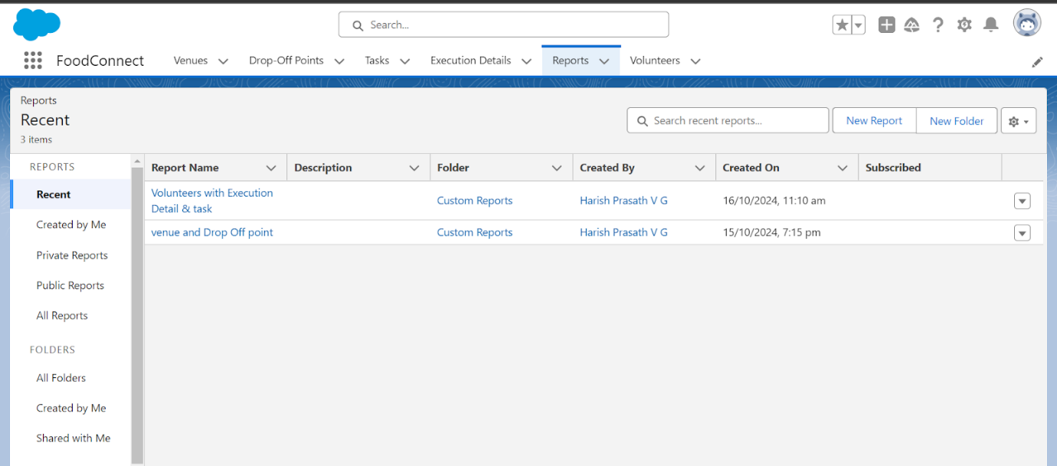

13. Developed a Dashboard

* A centralized dashboard was designed to display project metrics, including the number of venues, volunteer activities, food quantities, and distributions.
* The dashboard provided a real-time overview, improving transparency and making data easily accessible for quick decision-making.

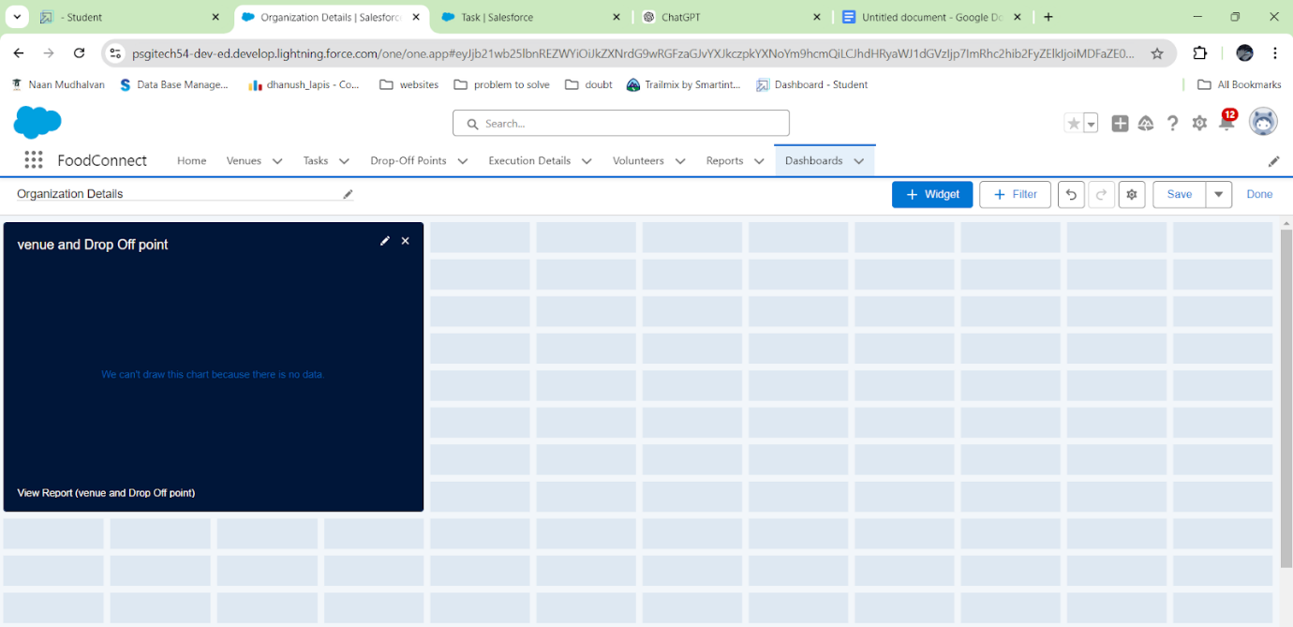

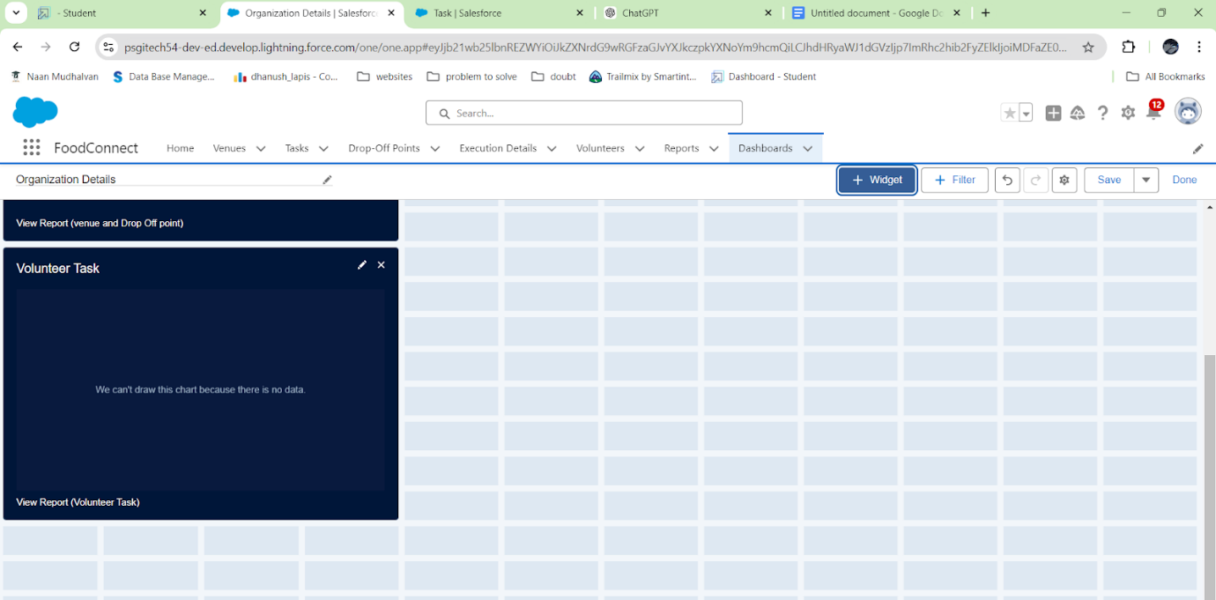

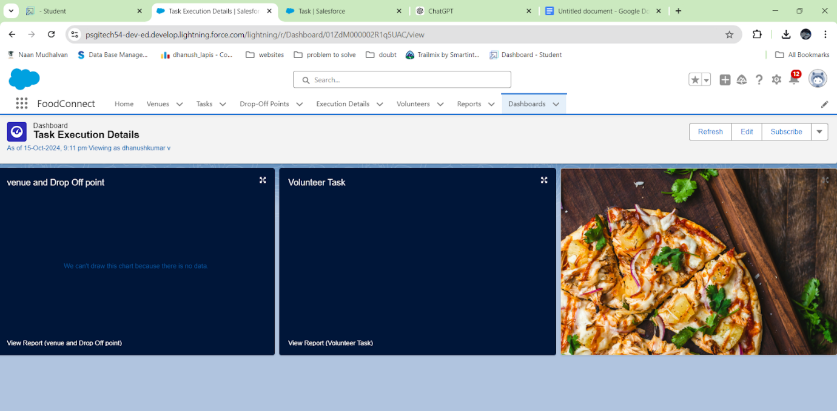

14. Configured Sharing Rules

* Sharing rules were set up to control record-level access, allowing specific groups to view or edit relevant data.
* This ensured that data privacy was maintained, while also enabling collaborative efforts where necessary.

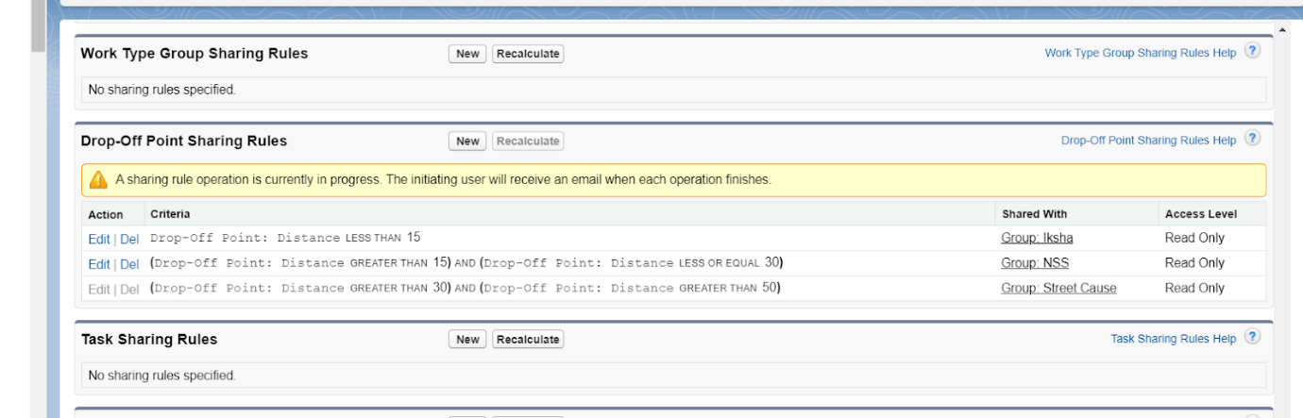

15. Integrated Dashboard with Homepage

* The dashboard was integrated into the Salesforce homepage to centralize access and enhance visibility.
* Key metrics, recent activities, and tasks were displayed on the homepage, making it convenient for team members to monitor the project’s status at a glance.

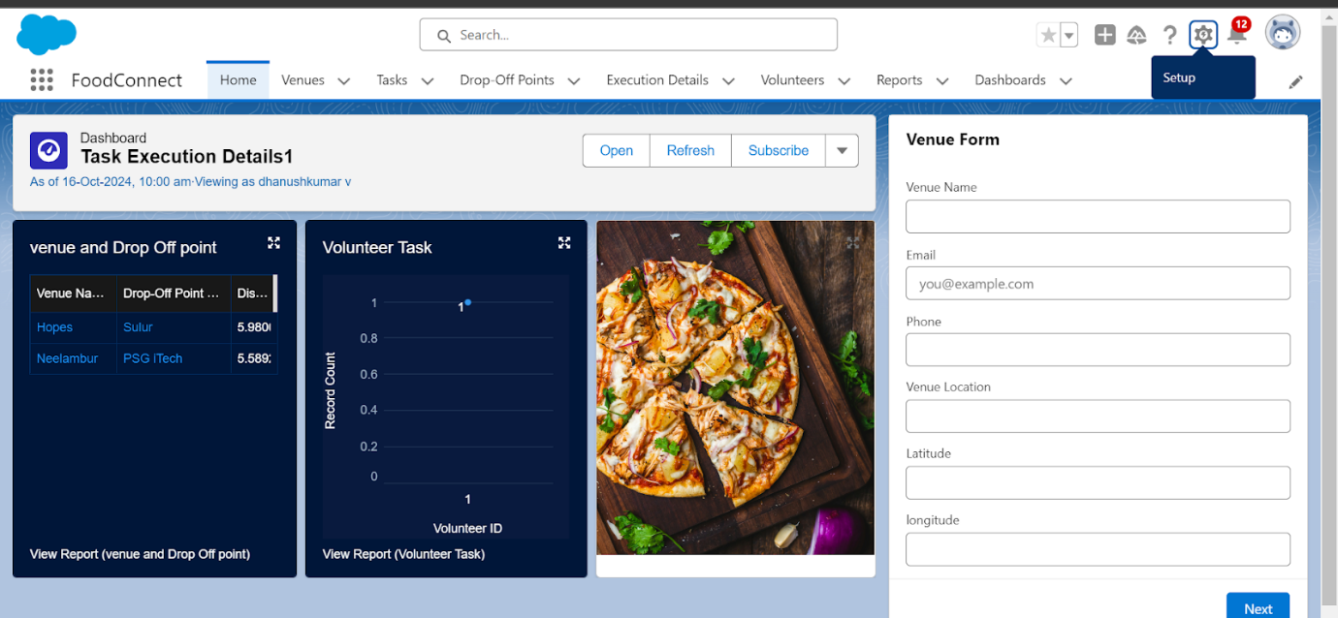

1. **Testing and Validation**
   1. **Unit Testing (Apex Classes, Triggers)**

**Apex Trigger:**

trigger DropOffTrigger on Drop_Off_Point__c (before insert) {

for (Drop_Off_Point__c drop : Trigger.new) {

drop.Distance__c = drop.distance_calculation__c;

}

}

**Test Class:**

@isTest

private class TestDropOffTrigger {

@isTest static void testDropOffTrigger() {

distance_calculation__c

Drop_Off_Point__c drop = new Drop_Off_Point__c(

Name = 'Test Drop Off Point’

);

insert drop;

Drop_Off_Point__c result = [SELECT Distance__c FROM Drop_Off_Point__c WHERE Id = :drop.Id];

System.assert(result.Distance__c != null, 'Distance__c should be populated by the trigger');

}

}

**STEPS:**

* Created a Test Record: Created a simple Drop_Off_Point__c record.
* Inserted the Record: Insert the record to trigger the trigger.
* Verified the Update: Check if the Distance__c field is updated by the trigger.
* Go to Setup > Apex Test Execution.
* Click Run after selecting your test.

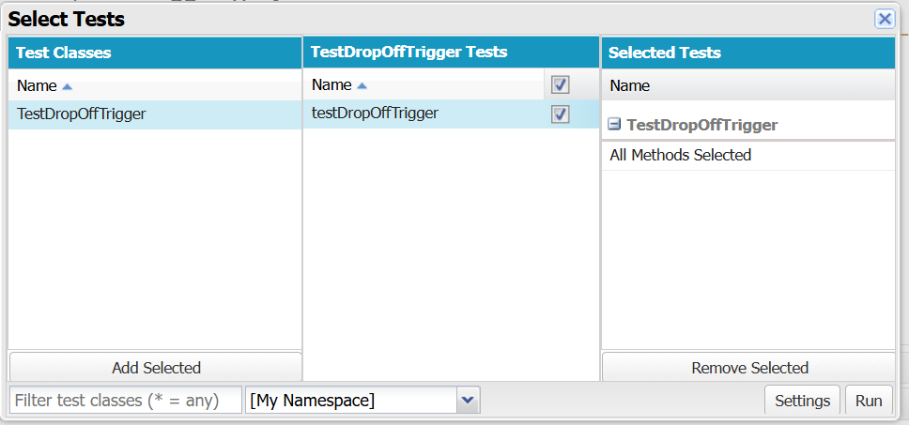

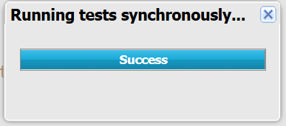

* 1. **User Interface Testing**

User Interface have been tested with various types of data and edge cases.

* Verify Layout: Ensure the dashboard loads correctly with all components (charts, reports, tables) visible.
* Check Data Accuracy: Validate that the displayed data matches the source reports or records.
* Test Filters: Ensure dashboard filters (e.g., date, region) update data correctly when applied.
* Check Interactivity: Verify clickable elements (charts, links) lead to the expected actions or pages.
* Test Responsiveness: Confirm the dashboard displays correctly across different devices (desktop, tablet, mobile).

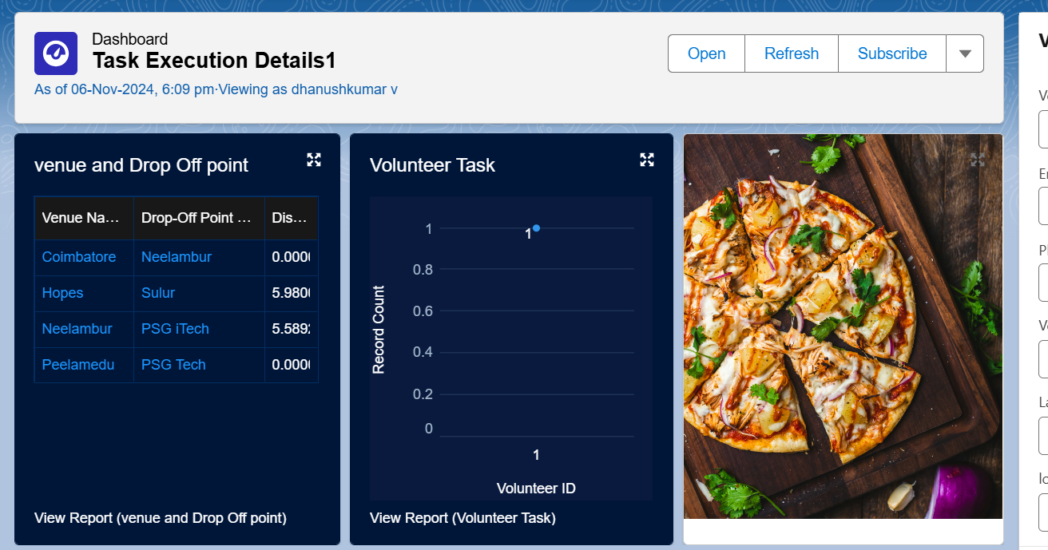

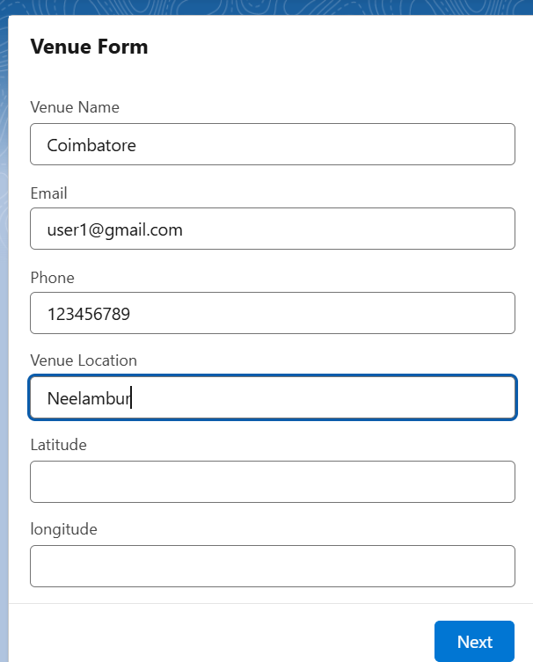

1. **Conclusion**

Summary of Achievements:  
The Salesforce Food Supply Project successfully created an efficient, transparent, and scalable system to manage the collection and distribution of surplus food to those in need. Key accomplishments include:

* Comprehensive Data Management: Implemented custom objects, tabs, and fields to manage critical data on venues, drop-off points, volunteers, tasks, and execution details, ensuring organized and accessible records.
* Automated Processes: Developed flows and Apex triggers for data entry and automation, enhancing operational efficiency by reducing manual input and improving accuracy.
* Enhanced Collaboration: Configured user profiles, public groups, and sharing rules to enable secure collaboration among participating organizations while protecting data privacy.
* Real-Time Monitoring: Created custom reports and a centralized dashboard integrated with the homepage to provide stakeholders with real-time visibility into project metrics and activities.
* Improved Decision-Making: Designed a structured, user-friendly system that streamlined the food distribution process, facilitating quick and informed decision-making.

The project achieved its primary objectives by leveraging Salesforce's platform, resulting in a robust system that supports the mission of providing food to the needy efficiently and transparently. This initiative exemplifies how technology can be used for impactful, community-driven projects.